Terraform

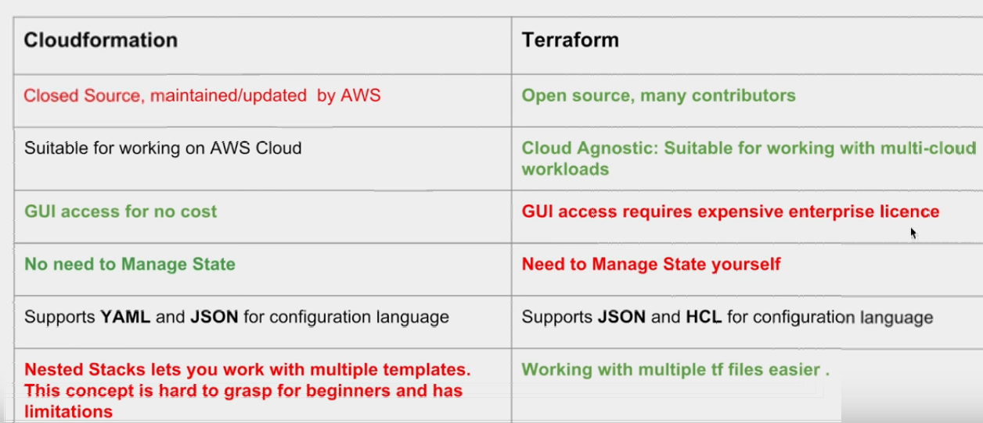

State file which maintains the current state of your infrastructure

Remote State Management – In this you move your local state file to terraform cloud which will help to manage terraform with multiple users as everyone could see state file on terraform cloud and you need to manually share your own state file.

This config stay in file “terraform.tfstay “ and backup copy in “terraform.tfstate.backup”.

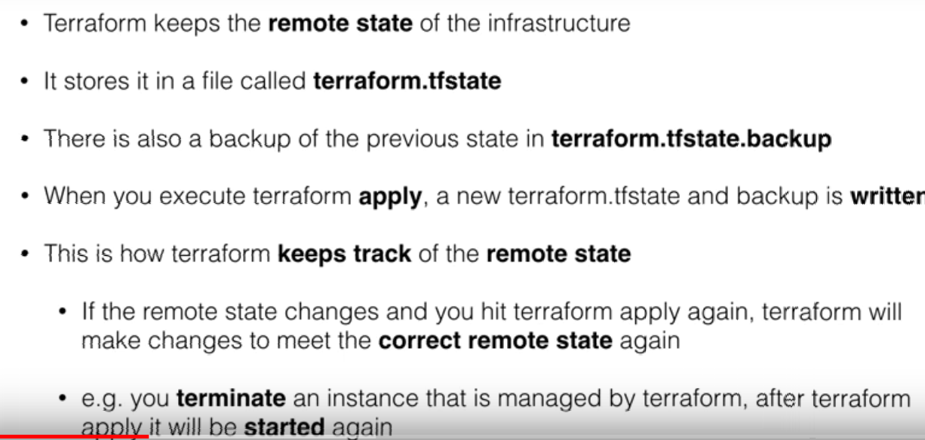

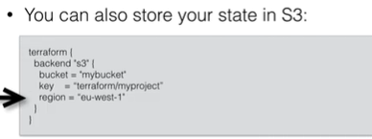

# terraform init – Initialize the terraform

#terraform plan – This command provide the list of changes in your state

# terraform apply – This command will apply all new changes captured in above command